LAB 5 – Operating Systems

Part A –

1. 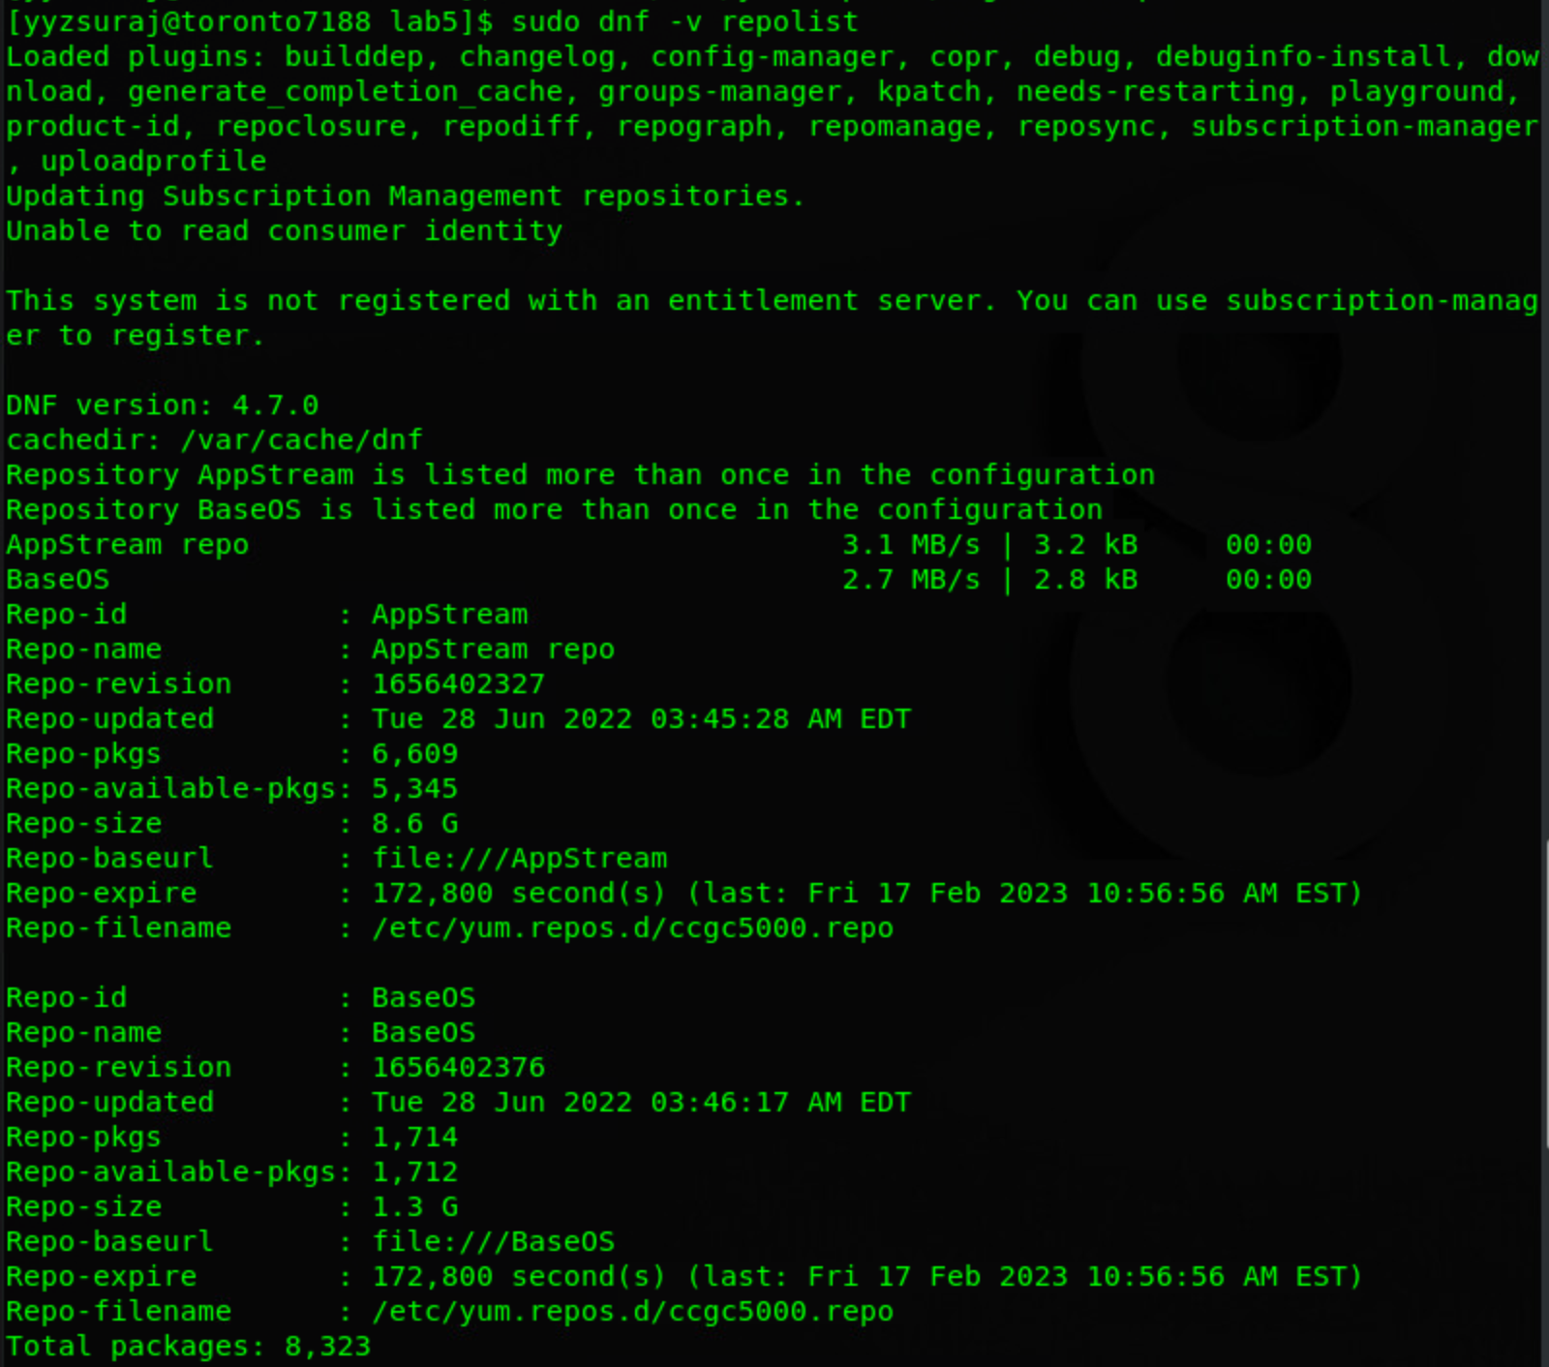  
     
     
     
     
     
     
     
     
     
   Next Page

SCREENSHOT - i)  
SCREENSHOT – ii)

5.f:

5.g:

Next Page

7.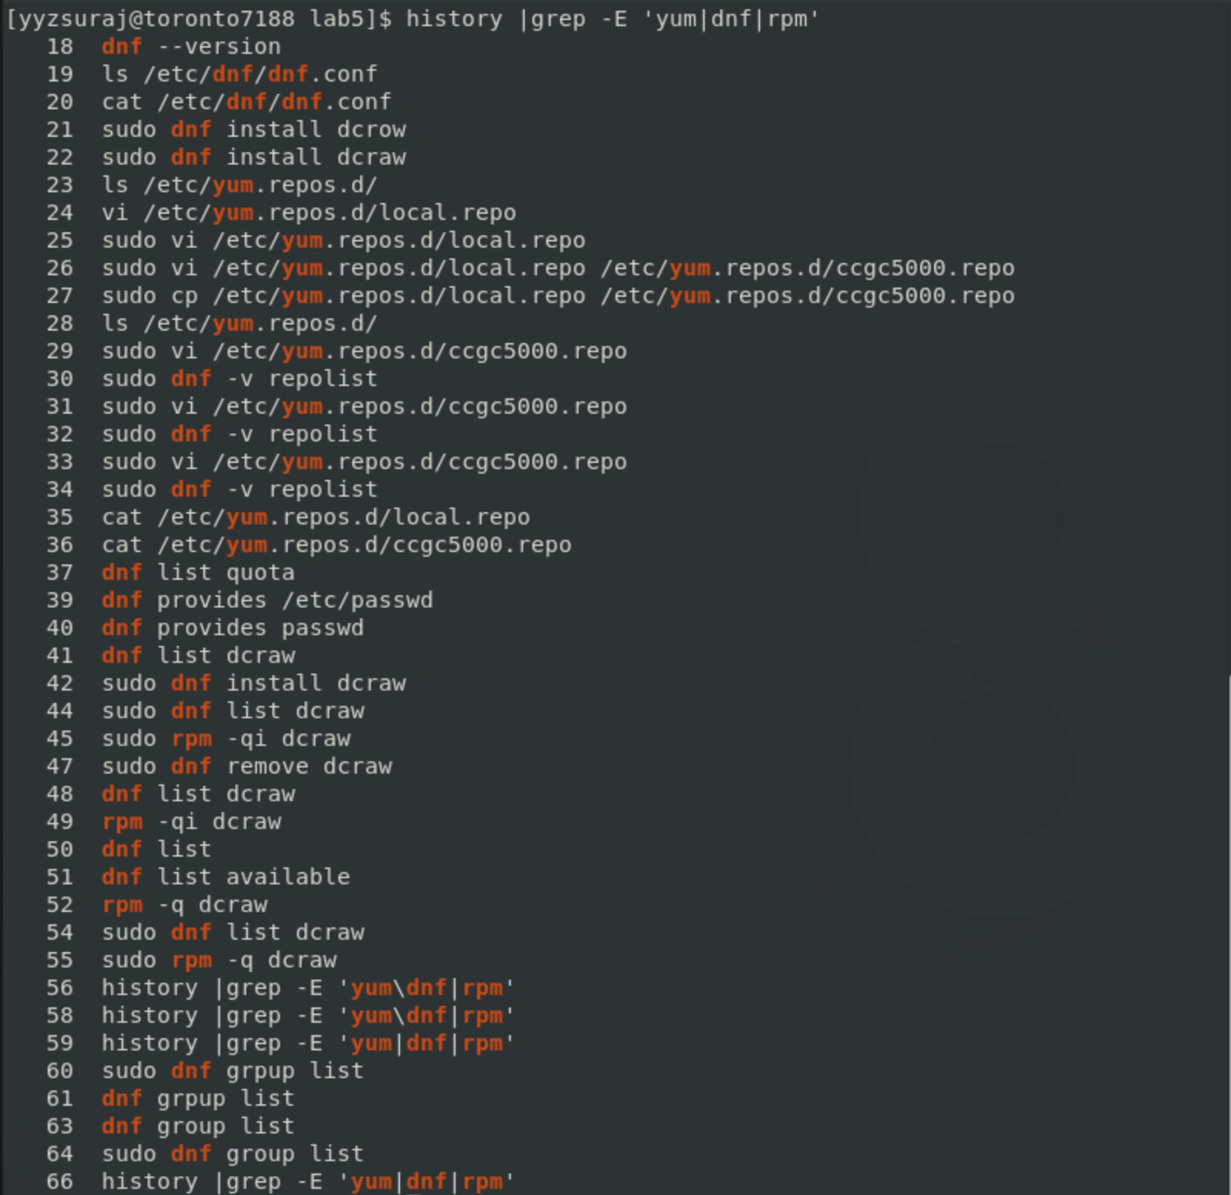

9.